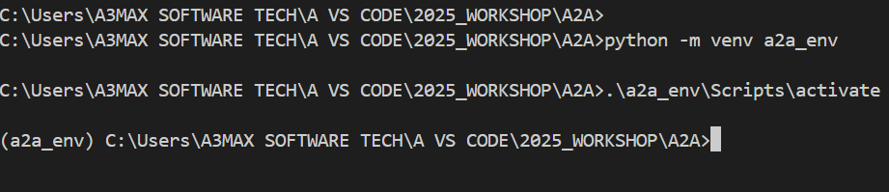

Next step is go to repo 🡪 <https://github.com/google/A2A>



Next step is follow up the documentation for uv install

Going further use uv instead of pip 🡪 <https://docs.astral.sh/uv/guides/install-python/>

Next step is to install uv 🡪

Next step is to install agents 🡪 crewi 🡪 dir

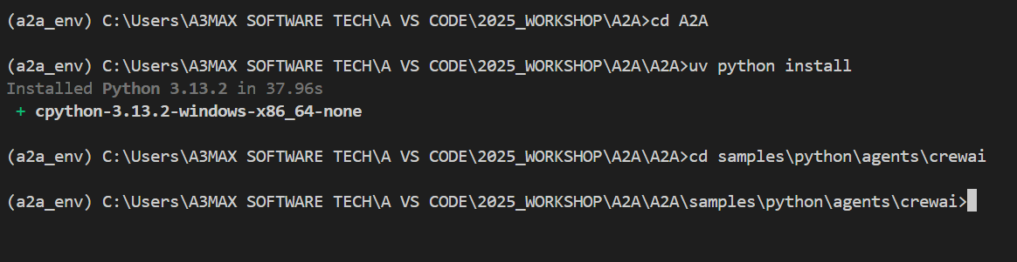

Inside crew ai 🡪 create a new environment (pip install python-dotenv)🡪 finally we create file called .env for (crewai, google_adk & langgraph) 🡪

Next step is need to run under crew ai🡪 uv run . 🡪 finally localhost has created

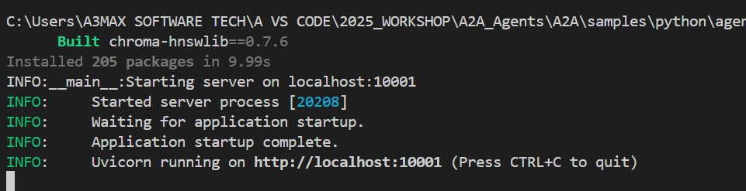

Create another terminal 🡪 vs code 🡪 change the prompt to google-adk 🡪 uv run . 🡪

Finally another terminal to langgraph 🡪 change the prompt to langgraph 🡪 uv run .

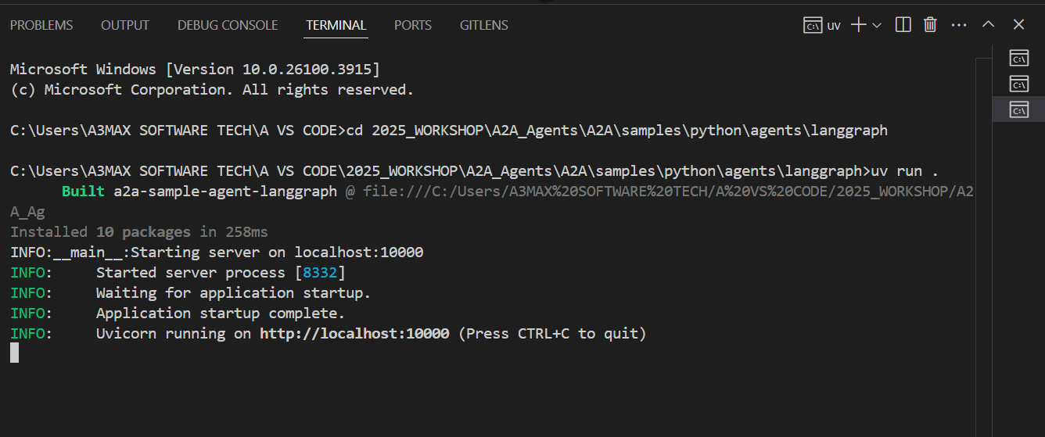

Lets create another terminal for ui 🡪 go to the demo location 🡪 cd ui 🡪 dir 🡪 uv run main.py

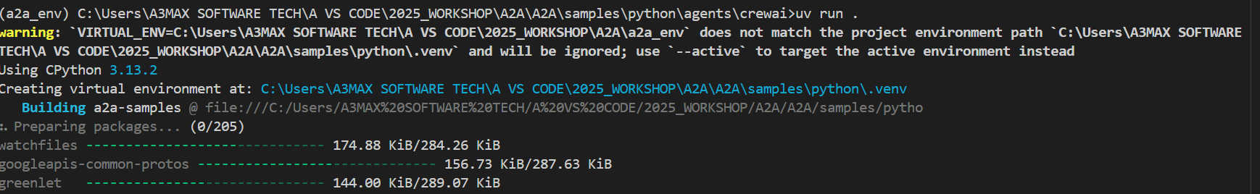

You might get below error 🡪so to fix this error you might need to install 🡪pip install chroma-hnswlib 🡪 still you got same error then need to download files from website (<https://visualstudio.microsoft.com/visual-cpp-build-tools/>) 🡪

Also need to select windows 11 🡪

You need to install 3 library (pip install crewai || pip install chroma-hnswlib || pip install chromadb==0.4.15) 🡪

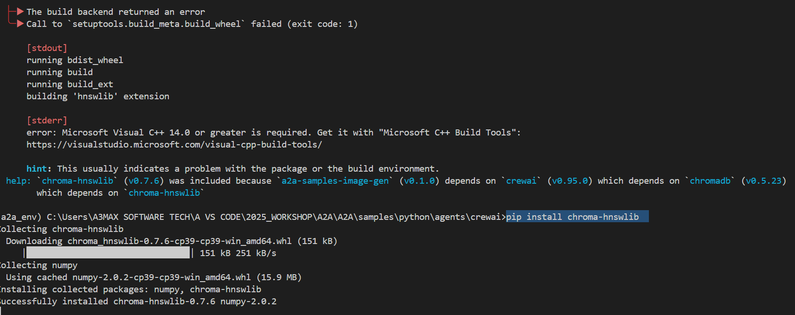

What are the agents available?

